I developed a program to scrape the webpage [http://www.dcnz.org.nz](http://www.dcnz.org.nz/)using the libraries xlsxwriter, requests, BeautifulSoup. I used the Eclipse IDE (Version: Oxygen 2 Release (4.7.2)).

I had to collect the information (contact, Scopes of Practice, Reg Number, etc.) from different doctors. There is a list box which permit us to filter by type of practice and text box to search by Surname, address, etc.

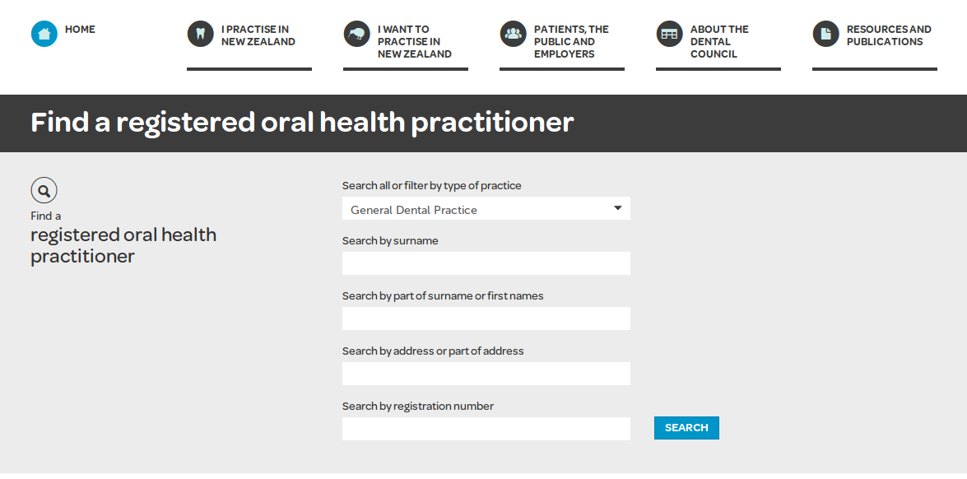

The search results are like:

